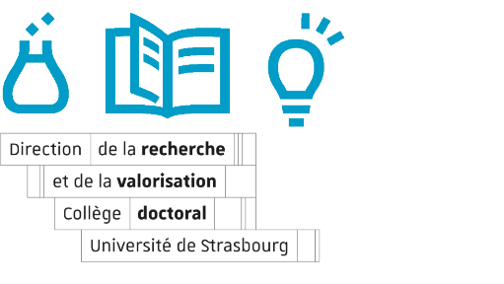
INFORMATION SHEET
contractuel·le doctorant·e
Doctoral School : ED 269 (ED MSII)

CANDIDAT·E
Civility : ☐ Mrs. ☐ Mr.
First name : Name (by birth) :
Marital Name (if applicable) :
INE number (national student ID) :
Insee number (social security number) :
Date of birth : city of birth :
Country of birth : Birth department (if France) :
Nationality : ☐ French ☐Autre to be specified :
Family situation : ☐ Alone without dependent children ☐ Alone with dependent child(ren)
☐ In a couple without dependent children ☐ In couple with dependent child(ren)
Number of children:

JDC/JAPD (French students only) : ☐ completed ☐ waiting for certificate
Personal address (track number and name) :

Postal code : city :
Mobile phone :
Professional phone (laboratory) :
E-mail (personal or professional):

ORIGINAL TRAINING
Last diploma obtained (Master, DEA, engineering diploma...):
Mention / Speciality :
Obtaining establishment :
Country of obtention : Year of graduation :
Are you the holder of the aggregation: ☐ YES ☐ NO
Are you a former student of an ENS: ☐ YES ☐ NO
Mention of the diploma: ☐ Fair ☐ Quite Well ☐ Good ☐ Very Good
Rank of classification (xx/xxx):

DOCTORAT
Thesis title :

Thesis director :
Civility : ☐ Mrs. ☐ Mr.
First Name : Usage name :
CNU section and/or CNRS section :
Member of the Institut Universitaire de France (IUF) ☐ YES ☐ NO
Management share : %

Thesis Co-Director 1 (if applicable):
Civility : ☐ Mrs. ☐ Mr.
First Name : Usage name :
CNU section and/or CNRS section :
Member of the Institut Universitaire de France (IUF) ☐ YES ☐ NO
Management share : %

Thesis Co-Director 2 (if applicable):
Civility : ☐ Mrs. ☐ Mr.
First Name : Usage name :
CNU section and/or CNRS section :
Member of the Institut Universitaire de France (IUF) ☐ YES ☐ NO
Management share : %

Research unit of affiliation:
Label and laboratory number :
Wording :
Laboratory address (track number and label) :

Postal code : city :

